

# Department of Information Technology, PICT Pune

Third Year Information Technology (2019 Course) 314458: Laboratory Practice-II (Cloud Computing)

Design and develop “TODO List Application” using Salesforce Cloud.

## Assignment no. 7

**Name and roll number of group members**

|  |  |
| --- | --- |
| **Rohit Pendse** | **33358** |
| **Harshal Rajput** | **33363** |
| **Shubham Saraf** | **33369** |
| **Atharva Sarwate** | **33370** |

**Guided by Prof. Sachin Pande**

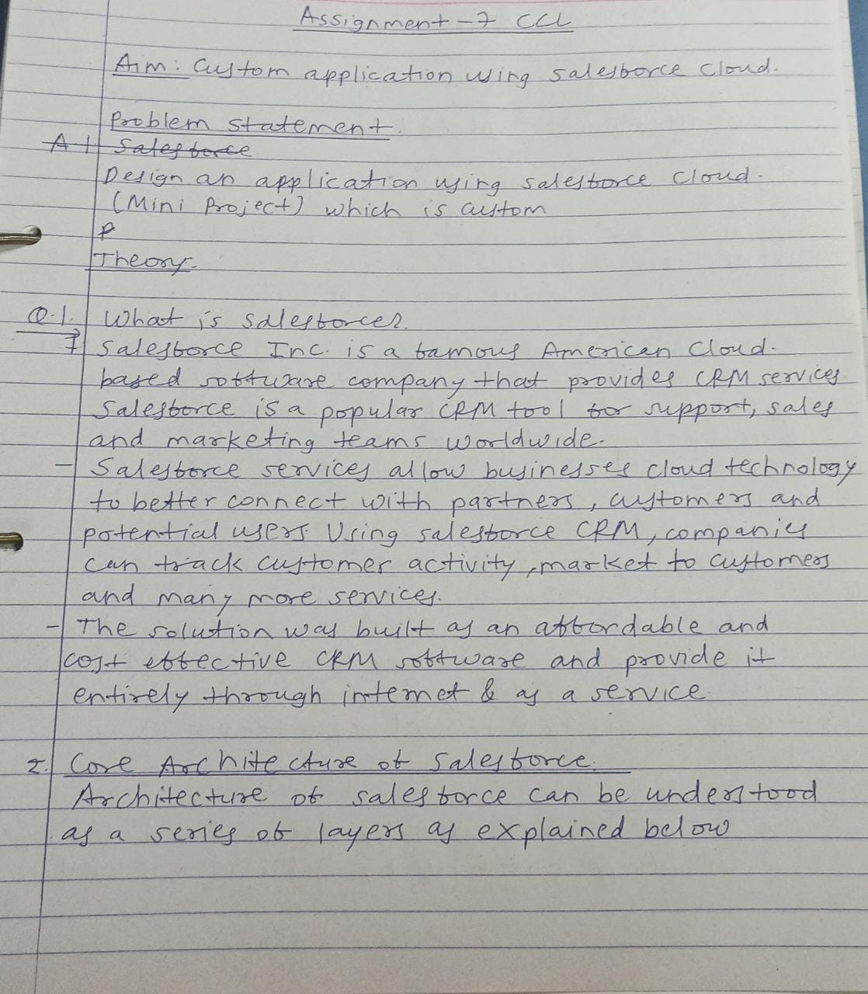

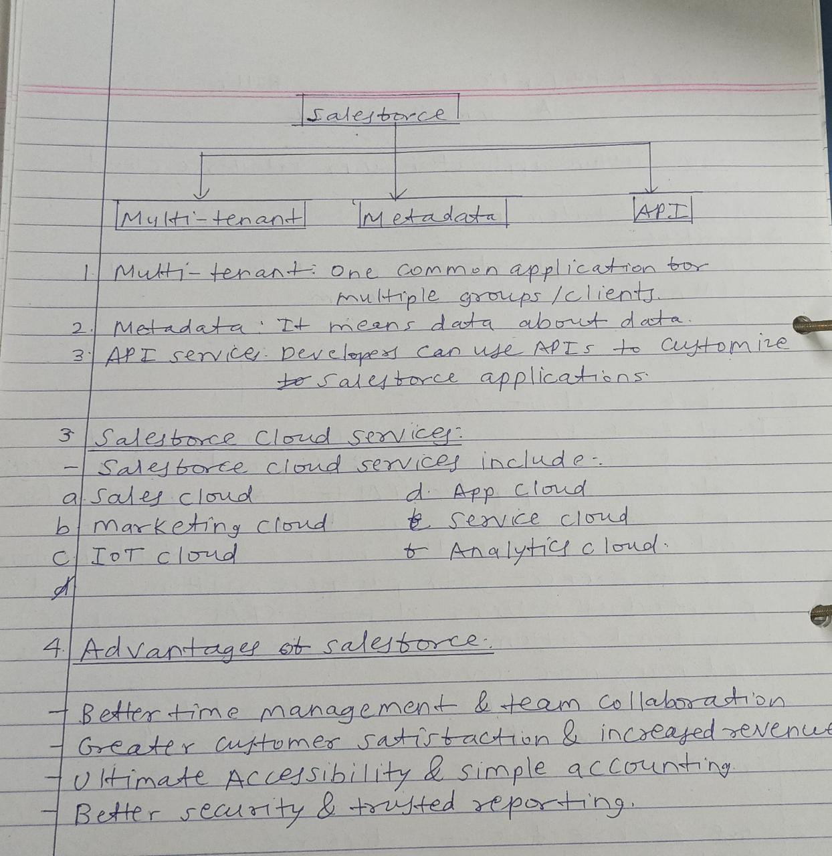

**INDEX**

|  |  |  |
| --- | --- | --- |
| **SR.NO** | **NAME OF THE PAGE** | **PAGE NO.** |
| 1. | INTRODUCTION | 5 |
| 2. | WORKING | 6 |
| 3. | FEATURES | 7 |
| 4. | SCREENSHOTS | 8 -13 |

## INTRODUCTION TO THE APPLICATION:

* Do you often feel overwhelmed by the amount of work you have to do? Do you find yourself missing deadlines? Or do you sometimes just forget to do something important, so that people must chase you to get work done?
* All of these are symptoms of not keeping a proper "To-Do List." These are prioritized lists of all the tasks that you need to carry out. They list everything that you have to do, with the most important tasks at the top of the list, and the least important tasks at the bottom.
* By keeping such a list, you make sure that your tasks are written down all in one place, so you don't forget anything important. And by prioritizing tasks, you plan the order in which you'll do them, so that you can tell what needs your immediate attention, and what you can leave until later.
* To-do lists are essential if you're going to beat work overload. When you **don't** use them effectively, you'll appear unfocused and unreliable to the people around you.
* When you **do** use them effectively, you'll be much better organized, and you'll be much more reliable. You'll experience less stress, safe in the knowledge that you haven't forgotten anything important. More than this, if you prioritize intelligently, you'll focus your time and energy on high-value activities, which will mean that you're more productive, and more valuable to your team.

## WORKING:

CRUD stands for -

* C: Create
* R: Read
* U: Update
* D: Delete

What is a ToDo List? The definition is a simple one. It’s a list of tasks you need to complete or things that you want to do.

Most typically, they’re organised in order of priority. Traditionally, they’re written on a piece of paper or post it notes and act as a memory aid.

Read More: What is a ToDo List? Simple tool to organise everything

* **Here are some of the basic features which we implemented in our application:**

**Create**

The create function allows users to create a new record in the list.

**Read**

The read function is similar to a search function. It allows users to search and retrieve specific records in the table and read their values. Users may be able to find desired records using keywords, or by filtering the data based on customized criteria.

**Update**

The update function is used to modify existing records that exist in the list.

**Delete**

The delete function allows users to remove records from a list that is no longer needed.

## FEATURES:

The features of property explorer app include the following:

1. Create a to-do list.
2. Implements basic CRUD operations.
3. Adding new task.
4. Accessing the new tasks in brief.
5. Updating new task.
6. Removing the task after completion.

## SOME SCREENSHOTS OF THE APPLICATION:

1. UI to create a new task:

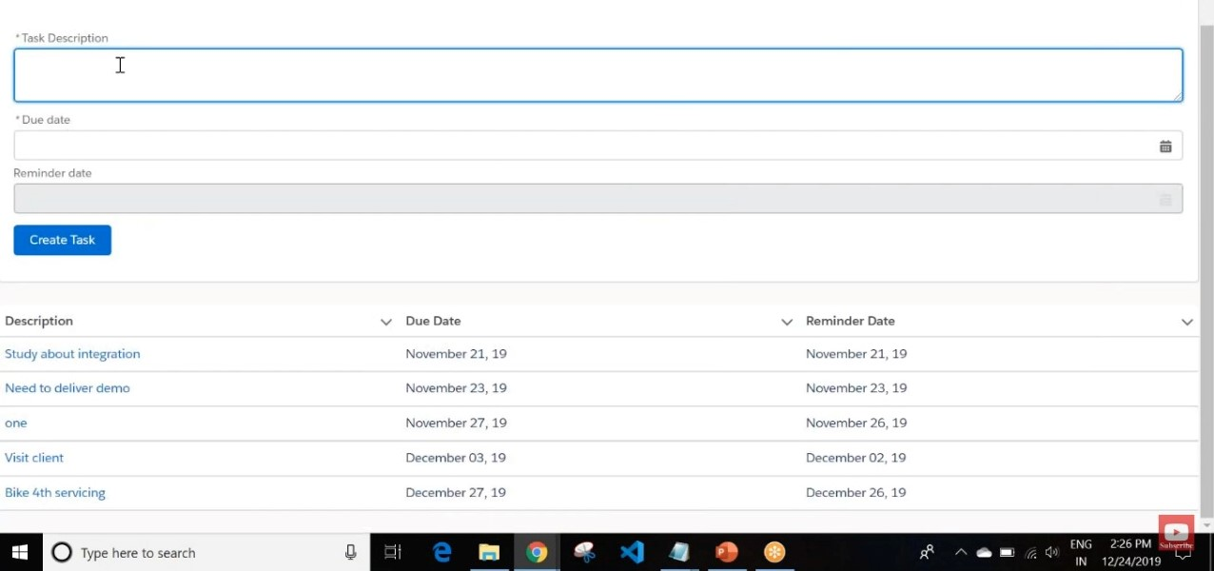

2. New custom object field on Salesforce cloud:

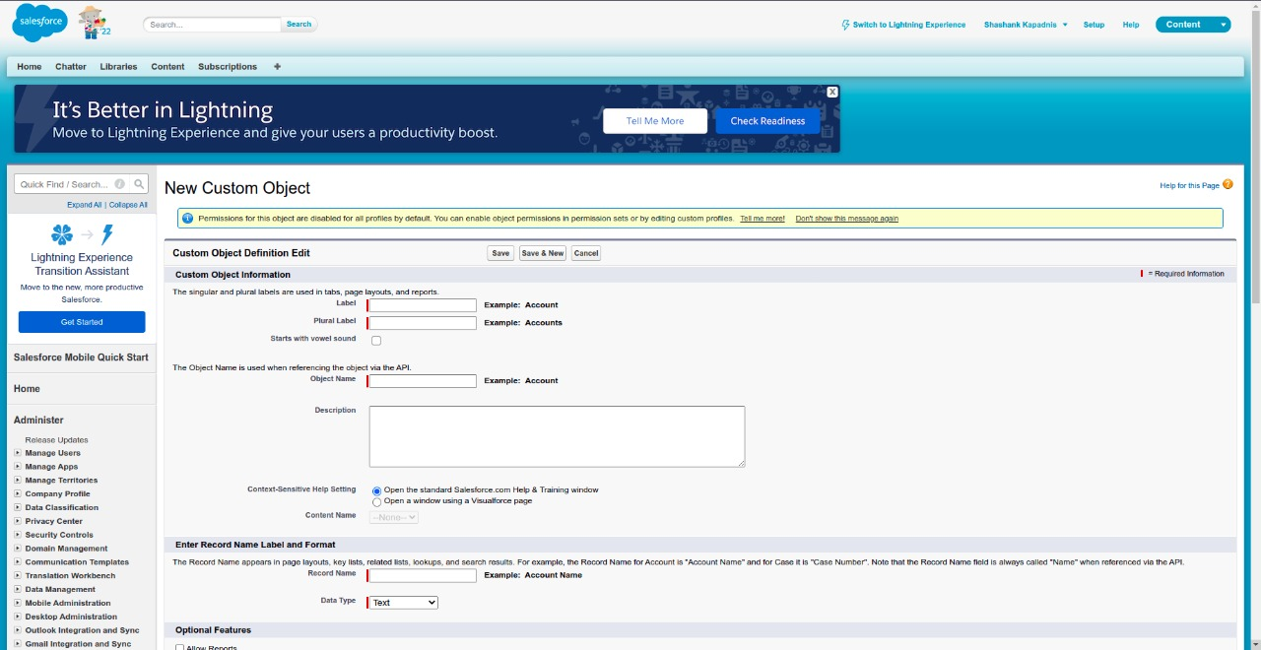

3. New Custom Object Tab:

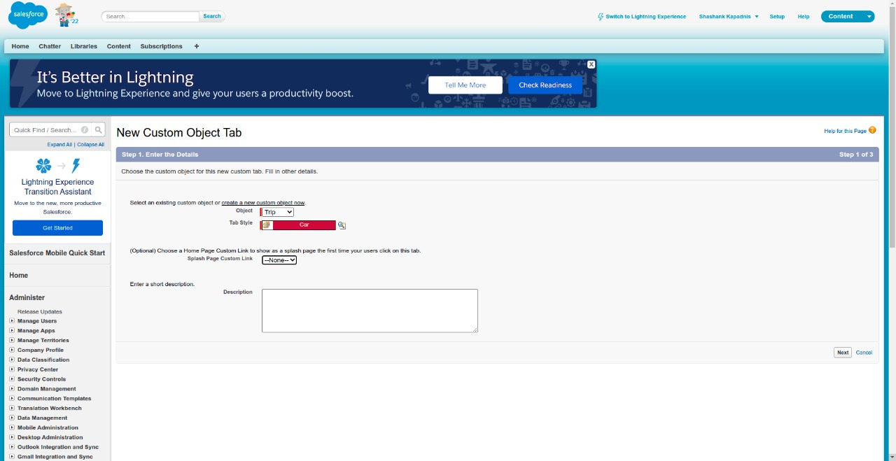

4. New Custom Field: (can be created using Field Label, Field Name, Description)

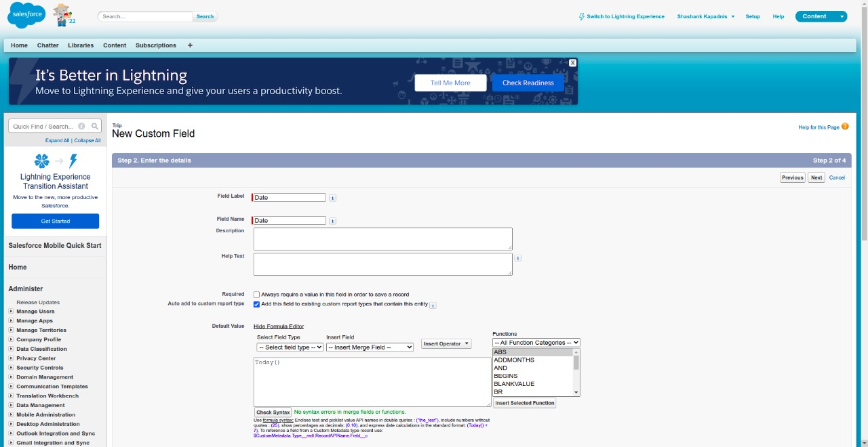

5. Specifies the type of information custom field will contain:

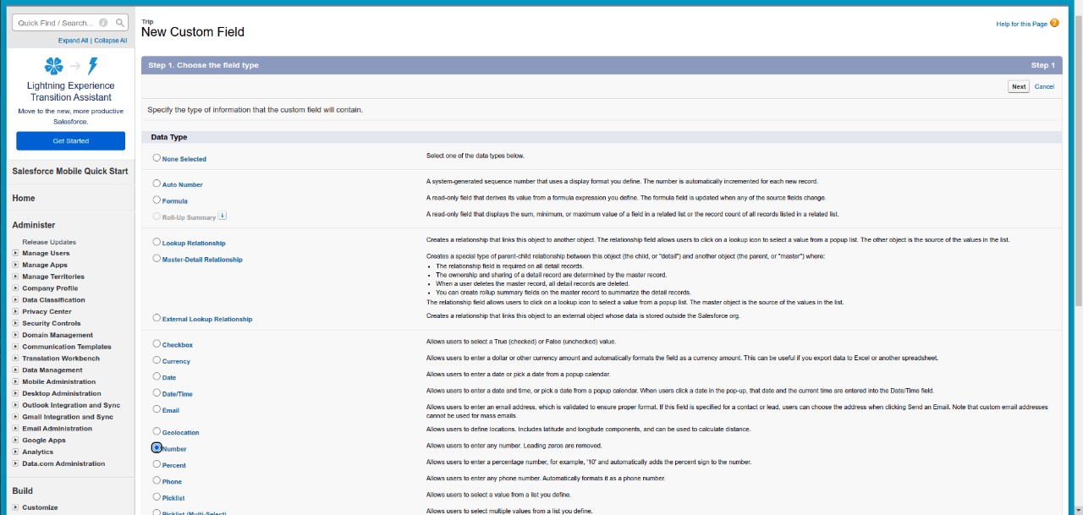

6 Validating Custom Field Attributes:

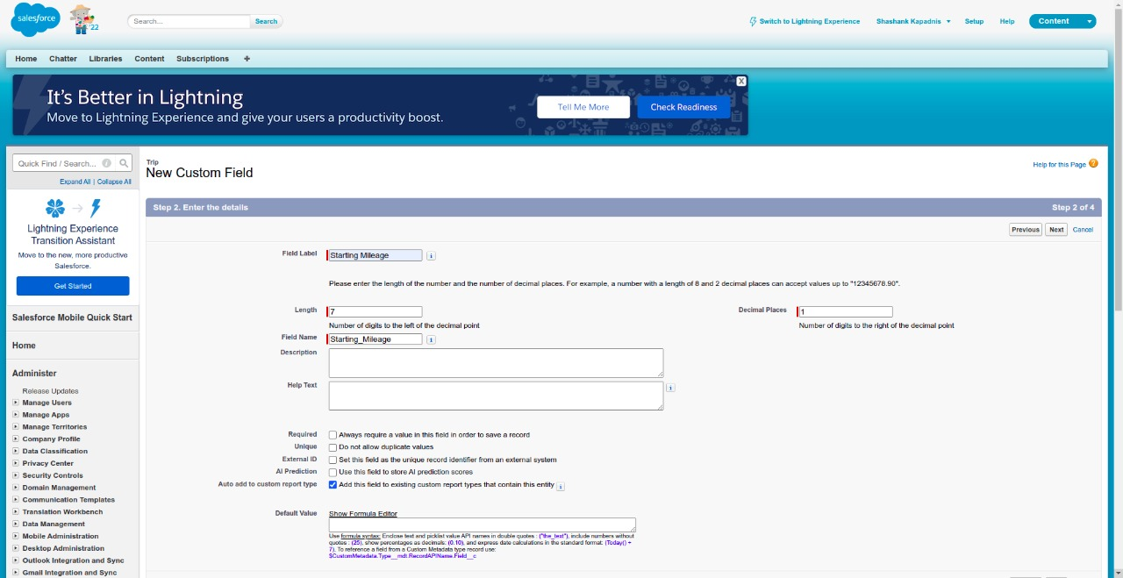

7. App Details and Branding:

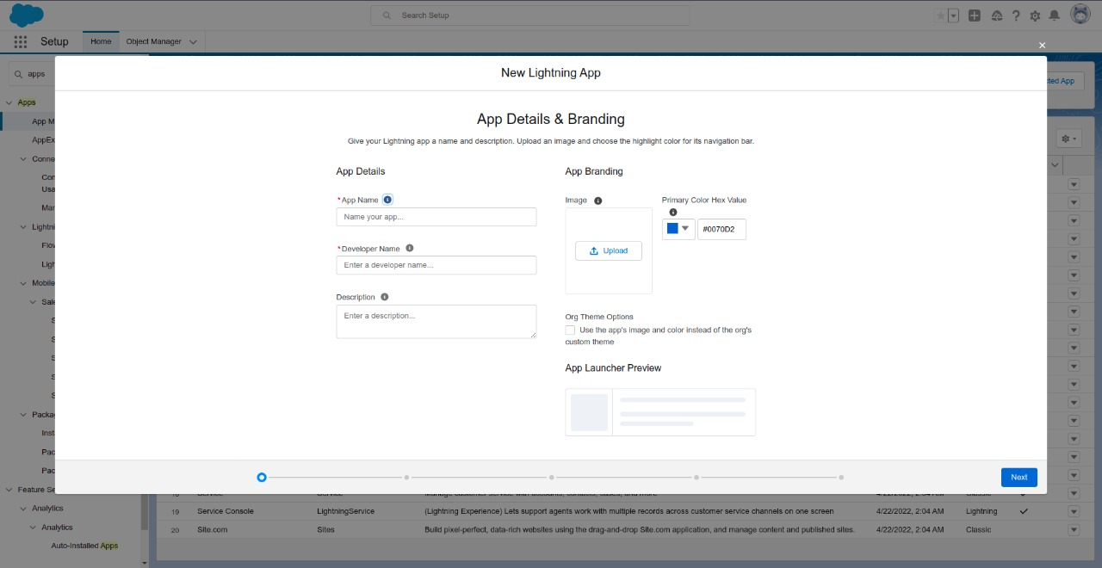

8. Data Logs:

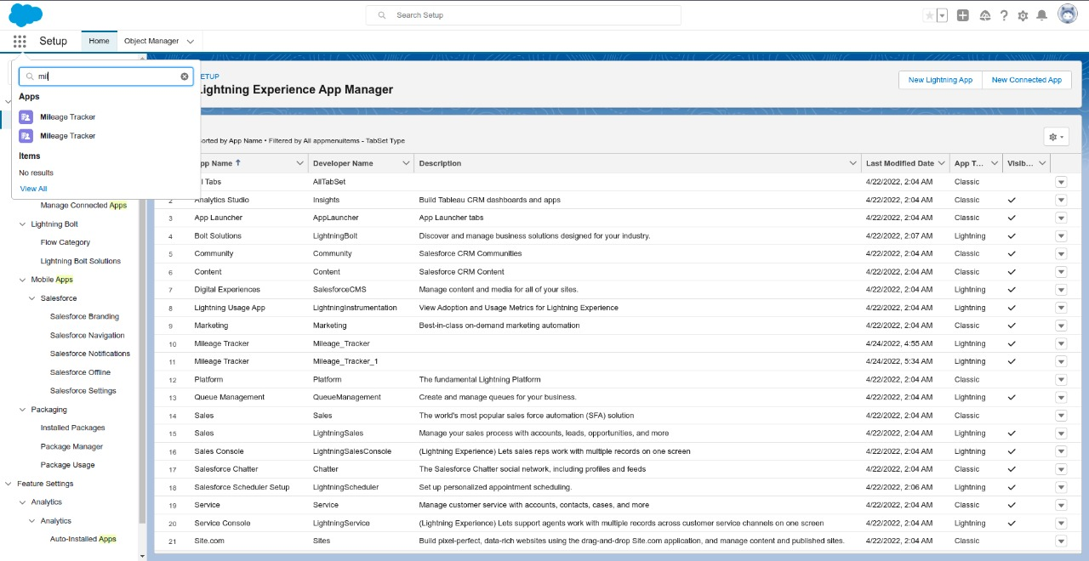

9. Available Data Types in Custom Fields:

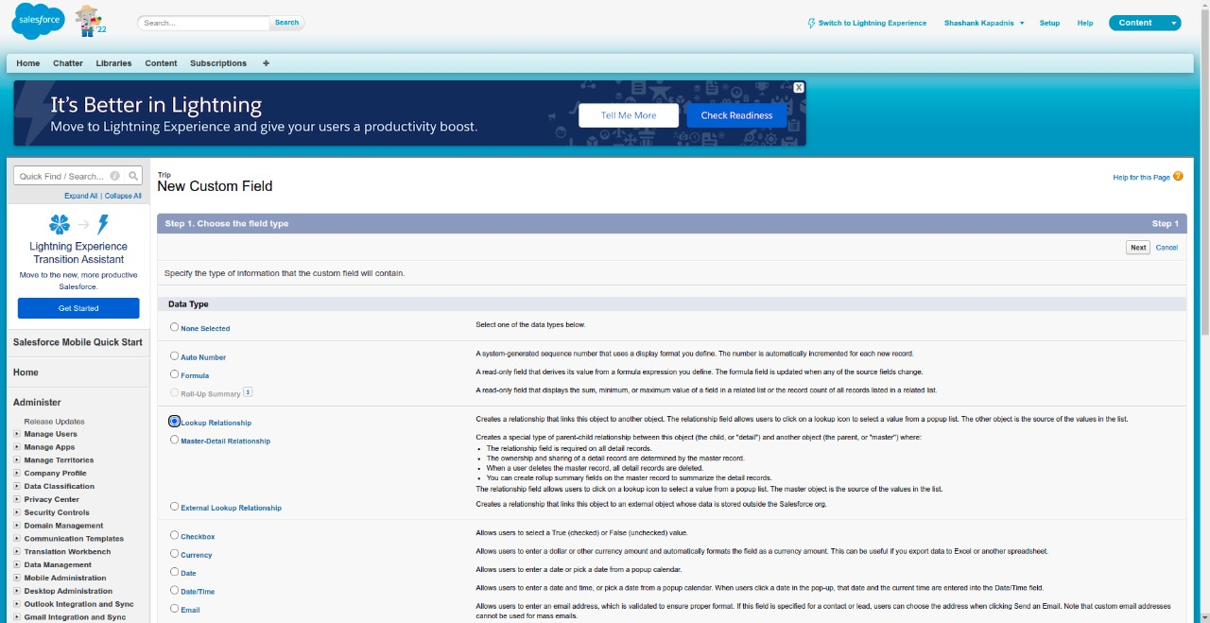

Conclusion:

